CHAPTER 8 - COMBUSTION DATA

### AVAILABLE HEAT CHARTS

Available heat for Birmingham Natural Gas (1002 Btu/cu ft, 0.60 sp gr) vs. % Excess Air and Combustion Air Temperature (at 10% excess air).

--- **60°*F*** Copyright 1983,GTE Products Corp., Towanda. PA 18848 USA

- - - - - - **10%** Excess **Air (preheated)** Used by Permission

90

,--.,.....,.....,....,-,--,--,--r"'-r---r---r---'--r---,----,-'-,-,--.,.....,....-,--,--,--,--r----r---r---,---,--,,--,--,

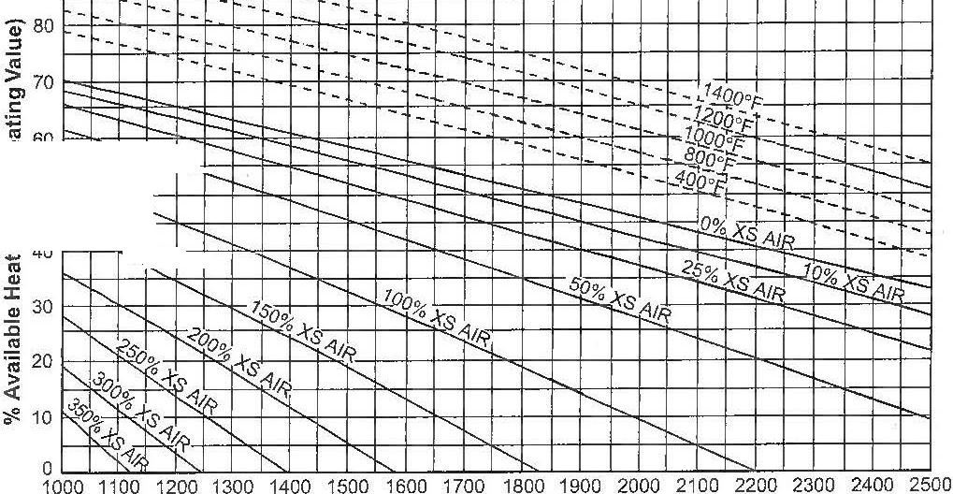

t-- ,

1---.

r-- ...

r--........

.......

r---........

1'-...

I---..

""-..

'

**Flue Gas Exit Temperature °F**

### AVAILABLE HEAT FOR VARIOUS FUEL GASES

These curves assume 0% excess air. The excess air curves above for Birmingham Natural Gas can be used **for** butane, propane, natural, mixed, coke oven, & carbureted water gas without more than 5% error in the available heat.

BUTANE 3200 BTU'\

\

I

PROPANE 2500 BT

'\

**r,..**

**r,..**

'

NATURAL GAS 1232 BTu ....

NATURAL GAS 1050 BTu

.......

**r-;::,...**

I

NATURAL GAS 967 BTu

I

*i*

!

'\

'

\

I\

'\

\

I

i'\

'\

'\

\

'

I

i

!

r,

I'\

I'\

\

'\

.....

\.

I

2400

2200

2000

1800

I

1600 **u:**

**:::i**

*(.)*

I

1400 **:i**

I

**ai**

1200 -;

**QI**

**:I:**

**QI**

1000 **:i:i**

I

**"iij**

\

800

..:::±-

£'-

7'--

'l---

'!-.:',

'\

'\ \

*'i-.*

MIXED GAS 800 BT*t*

**r--. .._**

,1

...........

-**-**--**-**-**-**-**r--....**

.........,. I

COKE OVEN GAS 600 B1u CARBURETED WATER GAS 534 BTµ-

COKE OVEN GAS 490 BTu

I

-----' -----

i----

_,

.........

t:-

"\I

#### \i\

*:::--*

......_;--....

....

- =--

600

400

I\\

BLUE WATER GAS 310 BTU ,-

I

PRODUCER GAS 157 BTLJ...!...

;u

PRODUCER GAS 116 BT

## -r--

- ;-::'::::-;;::I:::::>

i I I

,-....:

I

-

200

0

- -

200 600 1000 1400 1800 2200 2600 3000 3400 3800

**Flue Gas Temperature °F**

51



# FLUE GAS ANALYSIS CHART

"E

16 ''

'

' '

I I I

'' '

% CO2-#6 OIL

14

'' '

'

'

1/1 I

% 02 - DRY SAMPLE""

\

' '

12

\

''

, % CO2-#2 OIL

---- /

**/l,** I I

*v---****V***

I\ i_..--

rr-

-- --

---

[...,--'

*v*

*v-*

\

10

""

' '

",

''

'' '

' ,_

'

'

' '

'

'

-

'

/

*VV*

/

/

,,/'

% 02 - SATURATED SAMPLE -

8

I'-.

-

- -

'

-

'

....._

/

/ *V*

/

-/

*;,<,*--'

/. /

---

--

6

***/v/***

--..

,//

*V/'*

% CO2 - PROPANE

- I

-*r* --

--- --

-

r--

---

-

-- -- -- -

-

- --

-

-

-

-

-

r---

-

-

-

-

-

-

,- --

--

-

--

4

---

--

i---

--

-

-

---

---

r--

--

-

..

--

- -

2

*J1/*

*/J*

*I,V*

*I*

% CO2 - NATURAL GAS

I

*f*

**Cl)**

.a

:.:;

***ti>***

**C:**

**0u**

**<I)**

**(ll**

(!)

**Cl)**

;;,

i:i:

**0**

20 40 60 80 100 120 140 160 180 200

% **Excess Air**

Oxygen curves are plotted for 1002 Btu/cu ft Bim1ingham natural gas. These curves can be used for all common fuel gases and fuel oils with no more than 0.2% error in oxygen content.

Use the "02 - dry sample" curve with flue gas analyzers

that use dryers or condensers to remove water from the flue

# THEORETICAL FLAME TIP

gas sample. For analyzers which add water to produce a satu­ rated sample, use the "02 - saturated sample" curve.

% CO2 curves are based on typical propane and fuel oil anlyses. If the fuel composition differs, actual CO2 curves may vary slightly from those shown.

# HEAT TRANSFER RELATIONSHIPS

**TEMPERATURE VS. EXCESS AIR**

The maximum theoretical temperature of combustion gases at the tip of a flame decreases with increasing amounts of excess air. The curve bleow shows this relationship for natur­ al gas completely burned in 60°F combustion air, but is reaon­ sably accurate for most other common hydrocarbon fuels.

3200

|  |  |  |  |  |  |  |  |  |  |  |  |  |  |  |  |  |  |  |
| --- | --- | --- | --- | --- | --- | --- | --- | --- | --- | --- | --- | --- | --- | --- | --- | --- | --- | --- |
| I |  |  |  |  |  |  |  |  |  |  |  |  |  |  |  |  |  |  |
|  |  |  |  |  |  |  |  |  |  |  |  |  |  |  |  |  |  |  |
|  | I |  |  |  |  |  |  |  |  |  |  |  |  |  |  |  |  |  |
| I | |  |  |  |  |  |  |  |  |  |  |  |  |  |  |  |  |  |
|  | | \ |  |  |  |  |  |  |  |  |  |  |  |  |  |  |  |  |
|  | | \ |  |  |  |  |  |  |  |  |  |  |  |  |  |  |  |  |
|  | |  | \ |  |  |  |  |  |  |  |  |  |  |  |  |  |  |  |
|  | |  |  | I\.. |  |  |  |  |  |  |  |  |  |  |  |  |  |  |
|  | |  |  |  | "-- |  |  |  |  |  |  |  |  |  |  |  |  |  |
|  | |  |  |  |  | I'- |  |  |  |  |  |  |  |  |  |  |  |  |
|  | |  |  |  |  |  |  |  | |  |  |  |  |  |  |  |  |  |
|  | |  |  |  |  |  |  |  |  |  |  |  |  |  |  |  |  |  |
|  | |  |  |  |  |  |  |  |  |  |  |  |  |  |  |  |  |  |

#### Conduction

Q = kA (t1-t2)

L

#### Convection

Q = fA (t1-t2)

#### Radiation

Q AK (T~~1~~4-T24)

*.l_* + _J_l

P1 P2

Q =heat transferred, Btu/hr

A =surface area across which heat is being transferred, sq. ft.

t1 =temperature of heat source, °F t2 =temperature of heat receiver, °F

L =thickness of object through which heat is conducted

k =conductivity of material, Btu-ft

hr-sq ft-°F

.,

**:i lL**

3000

f =convection film coefficient, Btu-ft

hr-sq ft-°F

!L.. 2500

.; i:::

a. 0

E 2000

.E

K =Stefan-Boltzmann constant, "".1724 x 10-s Btu/sq ft-hr-{0R)4

P1 =emissivity of heat so1u-ce

7o E

a- i 0(..) 1500

.,

.



0 0"'

..c:- 1000

t- "

--

E -5

-

:, 0

P2 =emissivity of heat receiver

Ti =temperature of heat so1u-ce,0R T2 =temperature of heat receiver, 0R

0

( R =°F + 460)

·-E- 11.

")('0

500

0o 200 400 600 800 1000 1200 1400 1600 1800

% Excess.Air in Flue Gas

52



# THERMAL HEAD & COLD AIR INFILTRATION INTO FURNACES

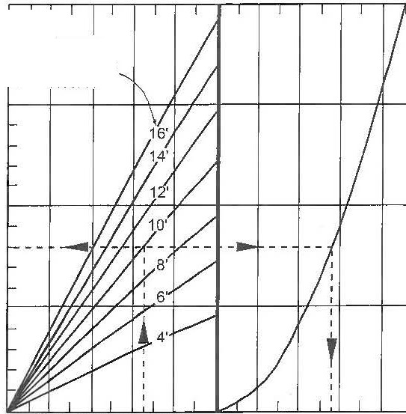20

Furnace Height Above

," Hearth

.15

**f**

**0**... "**C**'**: "O 0** "'::,

**0** >,

**Q.l CD**

The natural buoyancy of heated gases causes them to rise and collect under the roof of a furnace or oven. This creates a natural pressure differential, called thennal head or draft, which tends to pull cold air in through furnace leaks on top­ flued furnaces. These leaks are most pronounced at low fire, when burner combustion gas flow is insufficient to replace furnace gases drawn out by !hernial head.

This graph can be used to predict thermal head and cold air infiltration.

**Example:** Determine thermal head and cold air infiltration

-**:i::** ""''

**"'C,**

E o

.**Q**c**)** -:.,

I-::,

'- **Cl**

"

"***E***'

::,

**11.**

.10

.05

in a 10' tall furnace operating at I600°F.

**Solution:** Read up from 1600°F furnace temperature to the intersection of the IO' curve. Read to the left to find thennal head, 0.08" w.c. To determine air infiltration, read right to the infiltration curve and then down to the infiltration rate, 280 scfh per square inch.

0o 500 1000 1500 2000

**Furnace Temperature °F**

30

|  |  |  |  |  |  |  |  |  |  |  |  |  |  |  |  |  |  |  |
| --- | --- | --- | --- | --- | --- | --- | --- | --- | --- | --- | --- | --- | --- | --- | --- | --- | --- | --- |
|  |  |  |  |  |  |  |  |  |  |  |  |  |  |  |  |  |  |  |
| ....... |  |  |  |  |  |  |  |  |  |  |  |  |  |  |  |  |  |  |
|  | '---.. |  |  |  |  |  |  |  |  |  |  |  |  |  |  |  |  |  |
| ........... |  | ......... | ---.......  ---....... | .........  ......... | r---. | ......... |  |  |  |  |  |  |  |  |  |  |  |  |
|  |  |  | ......... |  | **r---.** |  | ......... |  |  |  |  |  |  |  |  |  |  |  |
|  |  |  |  | ----......... | | ......... |  | r--... |  |  |  |  |  |  |  |  |  |  |
|  |  |  |  |  |  | ---...... |  | ......... |  | ...... |  |  |  |  |  |  |  |  |
|  |  |  |  |  |  |  | ----.. | I'-.. | ...... | |  | ............... |  |  |  |  |  |  |
|  |  |  |  |  |  |  |  |  |  | ...... | ....... | ---............ | ............... |  |  |  |  |  |
|  |  |  |  |  |  |  |  |  |  |  |  | ---......---... | '---.. | ........... | ......... |  |  |  |
|  |  |  |  |  |  |  |  |  |  |  |  |  | ---...... |  | ........ | ---'. | |  |
|  |  |  |  |  |  |  |  |  |  |  |  |  |  | -...... | " | ----.. | ...... | ---....... |
|  |  |  |  |  |  |  |  |  |  |  |  |  |  |  |  | I'-.. | r--... | ----......... |
|  |  |  |  |  |  |  |  |  |  |  |  |  |  |  |  |  |  | ----....... |
|  |  |  |  |  |  |  |  |  |  |  |  |  |  |  |  |  |  |  |
|  |  |  |  |  |  |  |  |  |  |  |  |  |  |  |  |  |  |  |

20

100 200 300 400 500

Air Infiltration SCFH/ Sq. In.

**FURNACE FLUE SIZING**

**c**

--: 10

***r:T*** "'

(/)"'

**C,**

8

**g;**

**"1:-**

**-**"**1**'.**1**..**.**.

§ **0** 6

**u**., **au:** 5

"'(/)

**"**"'0 4

....**'**.**0**..

**co**

#### u ...

**Q)** .,

**.2 c..** 3

**11.**

2

2500°F

1500°F

500°F

Average Flue Gas Temp.

1

1 2 3 4 5 6 8 10 20 30 40 50

**Stack Height, Ft, Above Furnace Hearth**

These curves predict the flue area required per 1000 scfh of flue gases. based on the average temperature of those gases and the height of the furnace stack. Flue openings are assumed to be simple orifices with a discharge coefficient of 0.6, and all pressure drop across those orifices is provided by the ther­ mal head of the flue gases.

This method is conservative - it will produce generously sized flues.

Refer to Page 23 for volumes of combustion products for various fuels. Remember that if the combustion system is to be operated with excess air, the volume of combustion prod­ ucts has to be adjusted accordingly.

Average flue gas temperature will have to be estimated, taking into account the effect of stack heat losses and dilution air.

53

